**09 Nights / 10 Days Delhi & Himanchal Tour**

**Delhi – Dharamshala – Manali – Shimla – Delhi**

**DAY 01 ARRIVE DELHI**

Arrive at New Delhi’s Indira Gandhi International airport.

Delhi - the capital of India – The city consists of two parts - Old & New Delhi. Old Delhi was the capital of Muslim India between 17th and 19th century and has many mosques, monuments and forts. New Delhi, the imperial city was created by the British as the capital of India. In 1911, Edwin Lutyens, the most renowned English architect of the day, was chosen to design New Delhi which flaunts a surprising number of impressive monuments related to its conquests by the Mughals, Turks, Persians and ultimately the British.

Meet & Assist: A dnata representative meets you at the arrival hall of airport, and escort you to your hotel in air-conditioned vehicle.

Check-in at your hotel in Delhi for 2 nights.

Meals included: None

**Overnight: Hotel**

**DAY 02 DELHI**

Morning visit **Old Delhi** which was the capital of Muslim India between 17th and 19th century and has many mosques, monuments and forts. Begin your day with an exploration of Old Delhi - visit the **Jama Masjid**, the royal mosque built by the Mughal Emperor, Shah Jahan in 1656. It is one of the largest and most beautiful mosques in the world and is constructed in red sandstone and white marble. The main prayer hall has a seating capacity of more than 20,000 worshippers. In the old city of Delhi, walk through the by-lanes of the spice market, the wedding street and the jeweler’s lane to savor the 350 years old culture up-close. There will be great photo opportunities here.

Enjoy a **cycle rickshaw ride** through the narrow lanes of Chandni Chowk, the spine of Old Delhi. Jahanara Begum, the daughter of Shah Jahan designed this commercial place in 1648. **Drive past** **Red fort**, built in red sand stone by Shah Jahan in 1648, this magnificent monument is laid out along the river Yamuna as an irregular octagon. Drive through the majestic boulevards of New Delhi designed by the Edwin Lutyens in 1920. Lutyens' Delhi includes the grand government buildings and parliament house.

**The Rashtrapati Bhavan** (Presidential Palace) is where the Viceroy once lived and now is the official residence of the President of India. It is an imposing structure with 340 rooms, constructed high up on Raisina Hill. View India Gate, a war memorial arch built in honour of 90,000 Indian soldiers who lost their lives in World War.

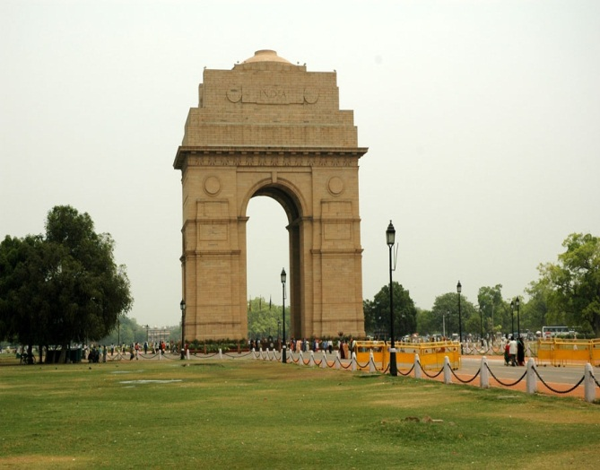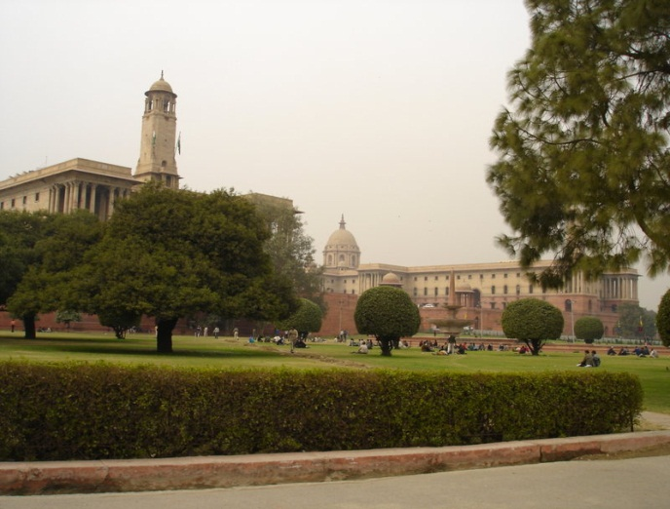

Continue to **Humayun’s Tomb**, the first great example of Mughal architecture in India, it developed to become the hallmark of the Mughal Dynasty. Culminate your tour at **Qutab Minar**, a soaring tower of victory, 72.5meter high with five distinct stories. The construction of this minaret commenced in 1193 and was completed in 1368. Built on the foundation of a Hindu temple, many elements of the construction reflect their Hindu and Jain origins. Within the complex, there are myriad monuments that combine both Islamic calligraphy and Hindu motifs.

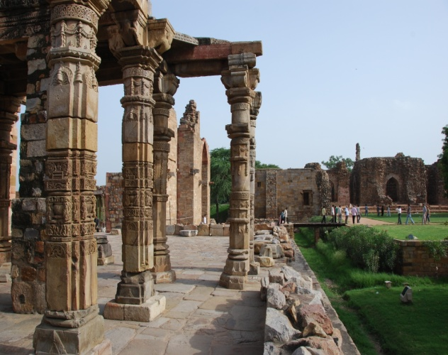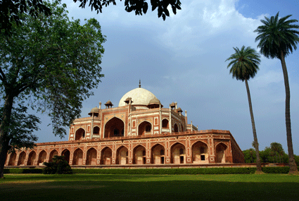

Return to hotel after the above visits.

**Meals - Breakfast**

**Overnight: Hotel**

|  |  |
| --- | --- |
|  |  |

|  |  |
| --- | --- |
| **DAY 03 DELHI – CHANDIAGRH - DHARAMSHALA**  Morning transfer to railway station to boar train for Chandigarh.  Upon arrival leave for Dharamshala.  Set against the backdrop of the dramatic Dhauladhar mountains, Dharamsala is perched on the high slopes in the upper reaches of Kangra Valley. The town is divided into two distinct and widely separated sections, Upper and Lower Dharamsala, which differ almost a thousand metres in height. We will be staying in Upper Dharamsala or Mcleodganj. Arrive Mcleodganj and transfer to Hotel. Evening free to explore the town.  **Meals – Breakfast & Dinner**  **Overnight: Hotel**  **DAY 04 IN DHARAMSHALA** |  |

|  |  |
| --- | --- |
| After breakfast full day sightseeing of Dharamsala.  **Norbulinka Institute :** Just four kms from Dharamsala, Norbulinka was established to preserve and teach the ancient Tibetan arts. The shady paths, wooden bridges, small streams tiny water falls make this place look like heaven. Here one can watch the wooden carvings and the tangka paintings, golsithing and embroidery being done. The nunnery close to the institute is a place where women are taught the advanced levels of Buddhist philosophy.  **McLeodganj :** Originally home of the semi-nomadic Gaddi tribe, McLeodganj is today the residence of His Holiness, the Dalai Lama. This mid 19th century place was developed as a British Garrison. The place was developed as an important administrative point for the whole Kangra valley. Today the place has developed as headquarters of the exiled Tibetan Government. The impressive monastery has larger than life size images of Buddha, Padmasambhava and Avaloketeshwara.  **Dall Lake :** Surrounded by high and green Deodar trees is the lake, which fills a mountain bowl. Situated 11-kms away from the town, this lake is easily approachable by road and makes an enchanting and serene picnic spot.  **Kangra Art Museum :** This treasure trove of the Kangra valley's arts, crafts, and rich past, displays artifacts that date back to the 5th century. The museum also includes a gallery of Kangra's famous miniature paintings and a representative collection of sculptures, pottery, and anthropological items.  **War Memorial :** Set amidst the pine groves is a war memorial, built on the entry point of the to Dharamsala to commemorate the post independence war heroes of Himachal Pradesh. A web of narrow paths and landscaped lawns lead towards this monument.  **Meals – Breakfast & Dinner**  **Overnight: Hotel**  After breakfast, depart for Manali by road (265 kms /06 hrs).  **DAY 05 DHARAMSHALA - MANALI**  Drive through the small markets and villages, well worth the time the moment you cross Bilaspur, Mandi, Kullu and other small markets. And start the run up along side the RIVER BEAS to Manali. The first sight of the Icy Mountains cradling this picturesque township in their fold seems so inviting that the foot on the accelerator gets a shade firmer. And the rumbles in your tummy no longer care for sickness but excitement.  On your arrival in Manali check into the Hotel.  **Meals – Breakfast & Dinner**  **Overnight: Hotel**  **DAY 06 IN MANALI** |  |

|  |  |
| --- | --- |
| After breakfast leave for sightseeing of Manali. Evening free at leisure. Overnight at Hotel.  **HADIMBA TEMPLE:** Manali has many attractions but the chief centre of interest, historically and archeologically, is undoubtedly the DHOONGRI TEMPLE dedicated to goddess Hadimba, the Bhim of Mahabharat fame. It has four-tiered Pagoda shaped roof and the doorway is carved with legendary figures and symbols. This temple located amidst wooden forest of deodar is about 2.5 kms. from the tourist office. It is a pleasant experience to stroll in the temple complex which was built in 1533 A.D. A large festival is held here in May.  **MANU TEMPLE:** 3 kms. from the main bazar in old Manali lies the temple of MANU RISHI. It is believed that this is the only temple of Manu in India, who was the creator of human race on the earth.  **CLUB HOUSE**: 2 kms. from the town, club house has indoor games facilities which has been located on the left bank of Manalsu Nallah. There are some picnic spots near it.  **TIBETAN MONASTERIES**: There are 3 newly constructed colorful monasteries, where visitors can buy carpets and other Tibetan handicrafts. Two are located in the town and one at Aleo on the left bank of Beas river.  **MOUNTAINEERING INSTITUTE:** Located 3 kms. on the left bank of river Beas towards Kulu. This Institute organises basic & advance training courses, in trekking, mountaineering, skiing and water sports. Skiing and trekking equipments can be hired from here by booking in advance. Tourists can visit an interesting showroom here.  **NEHRU KUND:** 5 kms. on National Highway to Leh,a natural spring of cold clear water named after Pt. Jwahar Lal Nehru, who used to drink water from this spring during his stay in Manali. This spring is believed to originate from the Bhrigu lake situated high-up in the mountains.  **Meals – Breakfast & Dinner**  **Overnight: Hotel**  **DAY 07 MANALI – SHIMLA**  After breakfast, depart for Shimla by road (260 kms /08 hrs). On your arrival in Shimla check into the hotel .  Shimla, the summer seat of the British Empire was discovered by Lt. Rose of the British Army in 1819. Patron goddess of the little village was Shamla Devi, and she gave her name to the settlement that sprang here. At an altitude of 2130 metres, Shimla straddles a Rhododendron and Conifer clad ridge, with settlements sloping down on both sides. A little steam engine chugs its way up forbidding inclines, trailing a leisurely handful of coaches. Shimla still retains its past historic splendours and is everything that it was in the good old days: wooden bungalows with gardens in which Gladioli and Hydrangea bloom; leisurely moments of horse riding, golf and cricket and fireside chats.  **Meals – Breakfast & Dinner**  **Overnight: Hotel**  Morning after breakfast proceed for full day city tour of Shimla visiting Indian Institute Of Advanced Studies, Sankat Mochan Temple and Jakhu Temple. Evening free to stroll in the famous shopping place of Shimla town - The Mall & The Ridge.  **DAY 08 IN SHIMLA**  **Jhaku Temple :** Best seen in the soft morning sunlight. This temple is on an incline. It takes about 45 minutes of walking from Scandal Point to get here. Dedicated to the monkey God Hanuman, there are a few real monkeys too many out here, but leave them alone and don't eat food around them, and you will be able to enjoy a spectacular view of the snow-bound mountains. The temple is believed to have the foot prints of Hanuman, and is located at a height of 2455 m and is the highest point of Simla Ridge.  **Viceregal Lodge :** Housed in the Gothic splendor of the Viceregal Lodge is the Indian Institute of Advanced studies, India's premier academy for higher research.  **Jakhoo Hill :** The steep climb to Jakhoo Hill, Shimla's highest point, is rewarding for superb views of the town and its surroundings. At the top is an old Hanuman temple.  **Meals – Breakfast & Dinner**  **Overnight: Hotel**  **DAY 09 SHIMLA – KALKA – DELHI** |  |

|  |  |  |  |  |  |  |  |  |  |  |  |  |  |  |  |  |  |  |  |  |  |  |  |  |  |  |  |  |  |  |  |  |  |  |  |  |  |  |  |  |  |  |  |  |  |  |  |  |  |  |  |  |  |  |  |
| --- | --- | --- | --- | --- | --- | --- | --- | --- | --- | --- | --- | --- | --- | --- | --- | --- | --- | --- | --- | --- | --- | --- | --- | --- | --- | --- | --- | --- | --- | --- | --- | --- | --- | --- | --- | --- | --- | --- | --- | --- | --- | --- | --- | --- | --- | --- | --- | --- | --- | --- | --- | --- | --- | --- | --- |
| Moring free.  Later in time drive to Kalka railway station to board train for Delhi (1745/2155 hrs).  Met on your arrival in Delhi and transfer to hotel.  Overnight in Delhi.  **DAY 10 LEAVE DELHI**  Breakfast at the hotel. Rest of the day at leisure in Delhi until transfer to the International Airport in time to board your flight home.  **===========END TOUR============**  **09 Nights / 10 Days North India Hill Stations**  **Delhi – Dharamshala – Manali – Shimla – Delhi**  **Per person cost in Dollars (USD)**  **All prices are net non-commissionable payable to dnata India**  **PACKAGE COST: VALID FROM 01ST JUNE TILL 30 SEPTEMBER 2017 ( Not valid during long weekends & Holidays)**   |  |  |  |  | | --- | --- | --- | --- | | **Details** | **Tour cost on Standard Hotels** | **Tour Cost on Superior Hotels** | **Tour Cost on Deluxe Hotels** | | **Tour cost on twin share basis** | USD 660 per person | USD 744 per person | USD 1031 per person | | **Single room supplement** | USD 289 per single | USD 374 per single | USD 666 per single |   **PS -  Quote is calculated on current USD value of 64 to INR. In case there is any steep change in exchange rate in near future will advise you. Also price given is based on current tax structure. In event of any new tax levied by government in near future will advise & bill you the difference if any.**    **PACKAGE COST: VALID FROM 01ST OCT TILL 31 MARCH 2018 ( Not valid during long weekends & Holidays & from 20 Dec till 10 Jan)**   |  |  |  |  | | --- | --- | --- | --- | | **Details** | **Tour cost on Standard Hotels** | **Tour Cost on Superior Hotels** | **Tour Cost on Deluxe Hotels** | | **Tour cost on twin share basis** | USD 667 per person | USD 770 per person | USD 1103 per person | | **Single room supplement** | USD 296 per single | USD 401 per single | USD 738 per single |   **PS -  Quote is calculated on current USD value of 64 to INR. In case there is any steep change in exchange rate in near future will advise you. Also price given is based on current tax structure. In event of any new tax levied by government in near future will advise & bill you the difference if any.**  **Hotel used or similar**   |  |  |  |  |  | | --- | --- | --- | --- | --- | | **City** | **3 star Hotels** | **4 star hotels** | **Deluxe hotels** | **Nights** | | Delhi | Hotel Anila | Piccadilly | Vasant Continental | 02 | | Dharamshala | Nandani Residency | Pride Surya Resort | Fortune Moksha | 02 | | Manali | Park Paradise | Manali Inn | River Country Resort | 02 | | Shimla | Him Dev | Ashiyana Residency | Radisson | 02 | | Delhi | Ajanta Hotel | Piccadilly | Vasant Continental | 01 |   **The Land cost includes-**   * 9 nights’ accommodation on twin share at the hotels mentioned above OR similar. In case of single room, please add single room supplement. * Daily breakfast at Hotel. * Half Board ( Breakfast + Dinner) at Dharamshala / Manali & Shimla * Transport using Medium Car for the entire tour as per the itinerary. A/c in Delhi. Non a/c in Hills * Services of English speaking local guide in each city as per the itinerary. * Entrance fee to monuments as per programme * Train fare in a/c chair for Delhi – Chandigarh & Kalka – Delhi sector. * All presently applicable taxes.   **The Land cost does not includes-**   * Expenses of personal nature like personal gratuities, telephone charges, laundry, spa activities, drinks, etc. * Meals not specified above. * Tipping to the guide, restaurants, driver and handyman. * International airfare, visa fee, airport tax and any kind of insurance. * Any Camera / Video Fees at the monuments. |  |